UNIT/01: THE MAN-MADE ENVIRONMENT

READING
IN THIS unIT YOU WILL
LEARN HOW TO
- skim a text quickly to understand the general idea
- scan a text for specific information to answer short-answer questions
- use skimming and scanning to locate the answer quickly
- understand and produce paraphrasing
- use the present continuous and present simple correctly.

Lead-in

 | A common topic in the exam is 'home'. Put these words under the correct heading in the table.
  01
  apartment | beach | bungalow | castle | ceiling | cellar | remote island
  city centre | countryside | castle | floor | garage | stone | glamorous
  leather | mountains | dining room | marble | modern | simple | skyscraper
  spacious | staircase | mansion | wood | window | gym
  Location | Building type | Style | Rooms | Parts of a room | Materials
  beach, city centre, mountains, countryside, remote island | apartment  skyscraper, bungalow, mansion, castle, garage | glamorous, simple, traditional, modern, spacious | cellar, gym, dining room | staircase, floor, ceiling, window | wood, marble, leather, stone
 | In pairs, use the vocabulary from exercise 1 to help you describe your dream home.  My dream house would be on the beach near the sea. it would be a simple bungalow with wooden floors. It would have a large dining room....
  02

SKIMMING AND SCANNING

◉ Skimming and scanning are important reading techniques which are very useful in IELTS. As time is limited in the exam, skimming and scanning help you to find the answers you need quickly.
You skim a text quickly to understand the general idea.
You scan a text quickly in order to find specific information.

 | For each activity, decide whether you would use skimming or scanning.  - looking up a word in the dictionary scanning  - browsing the internet for the latest news stories - skimming  - choosing a book from a library or bookshop - skimming  - finding a particular news story in a newspaper - scanning  - finding the price of a product in a catalogue - scanning  - looking through a magazine for an interesting article - skimming | TIP 03
  03
  Try to practise these or similar activities as much as possible.
  The more you practise, the better you will become at each technique.
 | The home in the photo cost about one billion dollars to build. What do you like or dislike about the design?
  04
 | Skim the text to understand the main ideas. | TIP 05
  05
  You are only reading for the main ideas at this stage, so remember to ignore unknown words.

A  Mukesh Ambani is one of the richest men in the world, and the first man to own a private residence costing more than one billion dollars to build. The home is on Altamout Road in Mumbai, one of the most expensive addresses in the world. Named after the mythical island Antilia, the property has 27 floors.  B  The interior of the home is very glamorous and each floor is made from different materials to give an individual look. Marble floors, rare wood and fine rugs are just some of the design features used to create this extravagant home. The lotus flower and the sun are common symbols used throughout. Many of the rooms have floor-to-ceiling glass windows, offering spectacular views of Mumbai and the Arabian Sea.  C  The skyscraper has a multi-storey garage with space for 168 cars. Alternatively, there are also three helipads on the roof of the building. The lobby has numerous reception areas and nine lifts. There are also several floors for dining, vast libraries and a health spa, including a gym, several swimming pools and yoga facilities. There is even an 'ice-room' which creates man-made snow, a Hindu prayer room and several floors of gardens. | D  The Ambani residence is clearly designed to entertain guests. It has a theatre which seats 50, several guest bedrooms and a grand ballroom filled with chandeliers.  E  The living quarters are on the top floors, because the family wanted as much sunlight as possible. The 400,000 ft² residence requires 600 staff, but all three Ambani children are required to clean their own rooms when they are at home.  F  Several experts have criticised the architecture of this very expensive home, comparing it to an 'unstable pile of books', Mrs Ambani, however, describes her home as 'an elevated house on top of a garden' and 'a modern home with an Indian heart'.  *helipad - a place where a single helicopter can take off and land

 | Answer these questions.  - When you were skim reading the text, which of these types of word did you focus on: prepositions, articles, names, verbs, adjectives, numbers?  names, verbs, adjectives, numbers  - Discuss with a partner what you remember about the text.  - What overall title would you give the text?  Antilia (Mumbai, India)  - Put the information in the order in which it appears in the passage.  - where the family live - 6  - opinions on the house - 7  - the materials used for the interior - 3  - the cost and address of the house - 2  - the facilities in the house - 4  - the owner of the house - 1  - information about the theatre and ballroom - 5
  06
 | Now scan the text for the information to answer these questions.  - Who owns the property?  Mukesh Ambani  - How many floors does it have?  27  - What are the floors made out of?  marble  - What are the common symbols used throughout the house?  the lotus flower and the sun  - How many cars does the garage have space for?  168  - How many people are required to work in the home?  d | TIP 07
  07
  In many of the IELTS reading tasks, the answers appear in the same order as the text.

PARAPHRASING

◉ 'Paraphrasing' is another important technique to understand and use in the exam. Paraphrasing is when you repeat something using different words, often in a simpler and shorter form that makes the original meaning clearer.

 | These statements paraphrase each of the paragraphs in the text.  Match each statement, 1-6, with the correct paragraph, A-F.  - The house has many desirable facilities and outside spaces. Guests can either drive or fly to the home. C  - The family live on the top floor because they want exposure to sunlight. E  - Mrs Ambani and the architecture experts have different opinions about the house. F  - Antilia is situated in Mumbai and owned by Mukesh Ambani. A  - The appearance inside the house is very extravagant and expensive materials have been used. The house also has magnificent views of the city. B  - The home is fully equipped to make visitors feel welcome. D
  08
 | Now scan the text for the information to answer these questions.
  09
  - desirable facilities - e  - outside spaces - f  - inside - g  - extravagant - c  - city - b  - visitors - a  - equipped to make visitors feel welcome - h  - expensive materials - d | - guests  - Mumbai  - expensive  - rare wood and fine rugs  - health spa and libraries  - gardens  - interior  - designed to entertain guests

[[[[[[[[[[SHORT-ANSWER QUESTIONS]
◉ Questions which require an answer of just a few words, like those in exercise 7, are a common feature of the exam. These are known as short-answer questions and they ask about factual details.

 | Choose NO MORE THAN THREE WORDS AND/OR A NUMBER from the passage for each answer.  - How many lifts does the home have?  9/nine  - What can you find in the ice-room?  man-made-snow  - What do the Ambani children have to do when at home?  clean their room(s) | TIP 10-11  TIP 10-11
  10
  The answers for short-answer questions come in the same order as they appear in the text.
  Remember to check that your sentences are grammatically correct when you have chosen an answer.
[[[[[[[[[[COMPLETING SENTENCES]
◉ A similar type of task, which also requires an answer of only a few words, is the 'sentence completion task'. The sentences paraphrase words and ideas from the text.

 | Complete the sentences. Choose NO MORE THAN THREE WORDS AND/OR A NUMBER from the passage for each answer.  - The name Antilia comes from a mythical island.  - There are many facilities to accommodate a large number of guests.  - Opinions on the architecture of the house vary.
  11

GRAMMAR FOCUS: PRESENT SIMPLE/PRESENT CONTINUOUS

 | A 'mindmap' is a type of diagram with lines and circles for organising information so that it is easier to remember. Put these words and phrases with the appropriate tense in the mindmap.  Present continuous: temporary, an action which is not complete, happening at the time of speaking  Present simple: repeated actions, general facts, opinions
  12
  temporary | repeated actions | general facts | opinions
  an action which is not complete |  | happening at the time of speaking
 | Using the rules in the mindmap, correct these sentences where necessary.  - Mukesh Ambani is living in Mumbai.  lives  - Mrs Ambani is believing that her home has an Indian heart.  believes  - The family live on the top floor because they want as much exposure to sunlight as possible.  correct  - When the children are at home, they are cleaning their own rooms.  clean  - Mrs Ambani entertains her guests in the ballroom at the moment.  is entertaining
  13

 | Complete the sentences using the word in brackets and the correct form of the present continuous or the present simple.  Currently, my mum is working (work) in the study.  I am / ‘m renting(rent) in the city centre for now.  I think(think) that buying a new house now would be a very good idea.  What is that going to be? They are / ‘re building(build) a new accommodation block for students.  Every day his mum cleans(clean) the house.
  14
[[[[[[[[[[MATCHING HEADINGS]
 | Using the approach below, read the text and answer the questions which follow.  Locating the answer: one approach  - Read the questions first, so they are in your mind when you read the text.  - Make sure you have understood the question correctly - underlining key words could help.  - Skim read the text for the main ideas. This will help you to have a rough idea of where to locate your answers on a second read-through.  Choose NO MORE THAN THREE WORDS AND/OR A NUMBER from the passage for each answer.  - What job did William Hearst do?  (newspaper) publisher  - Who helped Hearst design the Castle?  Julia Morgan  - How much did Hearst spend on art during his lifetime?  $3.5 million  - How many times was the Neptune pool rebuilt before Hearst was happy with it?  3 / three  - What were visitors to the Castle required to do every evening?  attend formal dinner(s)  - Who owns the mansion now?  the state of California  Complete the sentences. Write NO MORE THAN TWO WORDS AND/OR A NUMBER from the passage for each answer.  - As a child, Hearst enjoyed his holidays to Europe.  - Hearst inherited the land from his mother.  - Builders spent 15 / fifteen years creating the magnificent Neptune Pool.  - Hearst took animals from every continent for his private zoo.  - Although the zoo is now closed, zebras still walk about the hillside.  - The family donated the property because of (the) expensive maintenance.
  15

HEARST CASTLE
HOME | ABOUT | PHOTOS | BOOKING

A  William Randolph Hearst was a successful American newspaper publisher who received over 1,000 km² of land when his mother died in 1919. Initially, he had planned to build just a small bungalow, so he hired Julia Morgan, the first female architect in California. Together, however, they designed a magnificent castle which cost 10 million dollars and took 28 years to build. The property, named La Cuesta Encantada (The Enchanted Mountain), has 56 bedrooms, 61 bathrooms, 19 sitting rooms and about 52,000 m² of garden.  B  Hearst loved travelling to Europe when he was a child and we can see this in the overall design of the house. He even included cathedral ceilings and Roman columns in his home. Hearst was also a keen art collector and, during his lifetime, spent $3.5 million on his collection, which is displayed in the rooms at Hearst Castle. Today, his collection is worth much more, with one piece alone valued at $10 million.  C  One of the highlights of the estate is the Neptune Pool. It took 15 years to build and includes the front of an ancient Roman temple. It is on top of a hill and has wonderful views of the mountains, ocean and main house. The pool was rebuilt three times until he was satisfied. | D  Although the inside of the house is very European, the outside is very Californian, with palm trees and water. Hearst loved trees and 70,000 were planted on the property during his lifetime. The castle was also home to the world's largest private zoo, holding animals from every continent. Although the zoo is now closed, zebras can still be seen on the hillside.  E  As well as the Casa Grande (the main house), there are also three guest houses on the property: Casa Del Monte, Casa Del Sol and Casa Del Mar. Hearst entertained a great number of Hollywood stars and political leaders at the castle and many used his private airfield. Guests had to attend formal dinners every evening, but were free to do what they liked during the day. They were invited to stay as long as they wanted, but the longer they stayed, the further away they sat from Hearst at the dinner table.  F  When Hearst died in 1951, his family learnt how expensive maintenance would be, and the mansion was donated to the State of California. Since then, it has been open for public tours and the site attracts millions of tourists every year. However, the Hearst family is still allowed to use it when they wish. The castle was never completed and remains unfinished.

UNIT/01: THE MAN-MADE ENVIRONMENT

WRITING
IN THIS unIT YOU WILL
LEARN HOW TO
- select key features of different types of graph, chart and table in order to describe them accurately
- use suitable verbs, adjectives and adverbs to describe trends in different ways
- compare different graphs or information in the same graph and write a summary of the main features.

Lead-in

◉ In Writing Part 1, you could be given graphs/charts or tables to write about, so it is important to be very familiar with this kind of vocabulary.

 | Look at these examples of the types of diagram you might encounter in the IELTS exam. Then label the diagrams with words from the box.  - line  - horizontal axis  - vertical axis  - bar chart  - bar  - key  - title  - pie chart  - segment  - table  - column  - row
  01
  row | line graph | bar chart | column | horizontal axis | key | title
  bar | pie chart | segment | table | vertical axis | line
  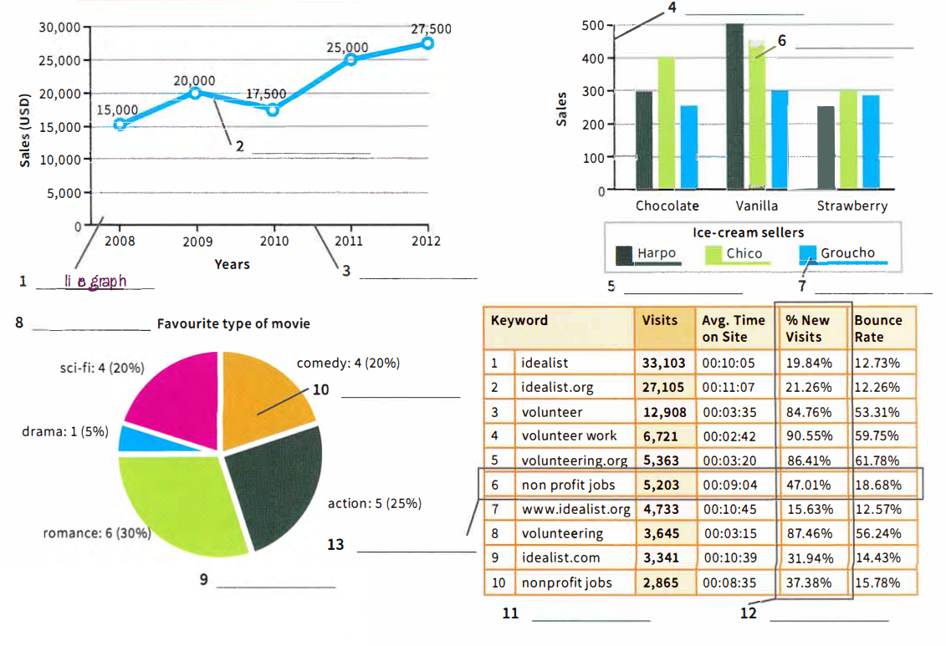

SELECTING KEY FEATURES

 | Study these graphs and make notes about their main features -use questions 1-12 to help you.
  02
  - What does the title say the graph is about?  The world's most expensive cities  - What does the vertical axis describe?  The cost per square metre in US dollars  - What does the horizontal axis describe?  Cities  - What do the columns/bars represent?  The cost per square metre in each city  - Which is the tallest and shortest bar?  shortest - Monaco; tallest - New York / Singapore  - How do the bars compare to one another?  Monaco, Hong Kong and London very similar; New York and Singapore significantly more expensive | 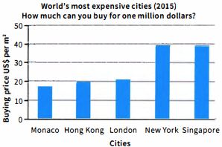
  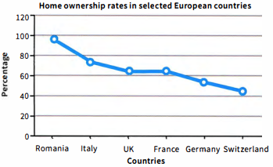 | - What does the title say the graph is about?  Home ownership in some European countries  - What does the vertical axis describe?  Percentage of people owning their own homes  - What does the horizontal axis describe?  Some European countries  - What do the highest/lowest points of the line show?  Romania has the largest percentage of homeowners and Switzerland the smallest.  - What is the general trend of the line?  Most of the countries have similar figures, except for Romania.  - Are there any sharp decreases or increases?  Romania has a much higher percentage of homeowners than the other countries.
  - What does the title say the graph is about?  Average house size in selected countries  - What do the segments represent?  Different countries  - Which is the largest/smallest segment?  Australia / Hong Kong  - Are some segments similar in size?  Australia / USA | 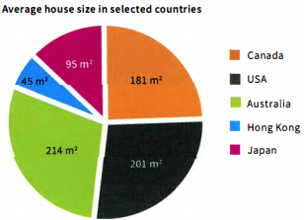
  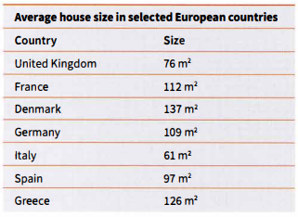 | - What does the title say about the table?  Average size of houses in selected European countries  - How many columns are there? What do they represent?  Two: country / size  - Which country has the biggest average house size?  Denmark  - Which country has the smallest average house size?  Italy  - Which countries have a similar average house size?  France / Germany

USING ACCURATE DATA

◉ It is very important that the information you provide in your answer accurately reflects the information given in the text.

 | The sample answer describes the pie chart and table in exercise 2.  Rewrite the sample answer, correcting any errors in data.  MODEL ANSWER  - The pie chart provides information about the average house size in selected countries and the table in selected European countries.  - the USA  - 45 m²  - selected  - most houses in Europe are much smaller than in the selected non-European countries  - Hong Kong
  03
  The pie chart and table provide information about the average house size 1 worldwide. According to the pie chart, the Australians have the most space with the average house size being 214m² This is perhaps because it is such a large country. The second largest houses are in 2 Canada with the average size being 201 m². The country with the smallest houses is Hong Kong, with residences being an average of just 3 45 m².
  In comparison, the table illustrates the average house size in 4 all European countries. The United Kingdom and Italy have the smallest houses and Denmark and Greece have the largest. The average house size in Denmark is 137 m².
  In conclusion, when comparing the two graphs, it is easily apparent 5 that houses in Europe are much smaller than in non-European countries.
  Overall, Australia has the biggest houses and 6 Italy has the smallest.. This is most probably due to the size of each country.
 | Did the writer make any other errors, not related to data? If so, what were they?  The writer did not make any errors with spelling or punctuation, but should not have included opinions ('This is perhaps because it is such a large country'; 'This is most probably due to the size of each country').
  04

USING ACCURATE DATA

 | Complete the words with the missing letters. Can you think of any more words for each category?  Possible other words: Rise - surge, shoot up, peak; Fall - reduce, collapse, tumble, diminish, sink, dip
  05
   | - Rise  - Increase  - CIimb  - Go up  - Rocket  - Soar |  | - Fall  - Decrease  - Decline  - Go down  - Plummet  - Plunge  - Drop | - Maintain  - Remain  - Stay
   |  |  |  | 
 | Answer these questions.  - Which of the verbs in the boxes are used to describe a sudden increase?  rocket, soar  - Which of the verbs in the boxes are used to describe a sudden decrease?  plummet, plunge
  06

 | When using these verbs, it is important that you also consider the tense used. Look at this example.  The number of young people buying property plummet last year. ✗  The number of young people buying property plummeted last year. ✓  Complete the sentences using the verb in brackets in the correct tense. There may be more than one correct form of the verb.  - Last year house prices rose(rise) by 5%.  - Monaco's property market remains / has remained / remained(remain) stable.  - The line graph illustrates that since 2010 home ownership has decreased(decrease).  - House prices are going to go up(go up) next year.  - In Ireland, property prices have rocketed(rocket) substantially this year.
  07

USEFUL ADVERBS AND ADJECTIVES

◉ Once you know the common verbs used to describe charts and graphs, it is important to add adverbs and adjectives to your sentences in order to demonstrate your range of vocabulary.

USEFUL ADJECTIVES

◉ Adjectives can be used to demonstrate your range of vocabulary. Adjectives describe nouns and usually come before the noun.
Note: these verbs are also commonly used as nouns.
to rise / a rise | to fall/a fall | to decrease / a decrease
to increase / an increase | to drop / a drop | to dip/a dip
to decline / a decline | to peak / a peak

 | Complete the table with the adjectives from the box.  *These adjectives usually go after the noun. | TIP 08
  08
  slight | modest | significant | dramatic
  stable | steady* | substantial | unchanged*
  Big change | Small change | Gradual or no change
  dramatic, substantial, significant | slight, modest | steady, stable, unchanged
  Make sure you know how to spell these adjectives correctly as it is common for students to make errors with these.

 | Complete the sentences using adjectives from the box in exercise 8 and following the prompts in the brackets. More than one answer may be possible.  - Over the last year, Hong Kong has experienced a significant/substantial / dramatic(big) rise in house prices.  - There has been a steady(gradual) increase in the number of young people buying houses.  - The rental market has seen a slight / modest(small) decrease over the last six months.  - The graph illustrates that the rental market is unchanged / stable / steady(no change) at the moment.
  09

USEFUL ADVERBS

◉ Adverbs describe how something happens and usually follow a verb.
For example:
- Last year house prices rose significantly.
- Last year house prices rose slightly.
- Last year house prices rose steadily.

 | Match sentences 1-3 with graphs A-C.  - C  - A  - B
  10
  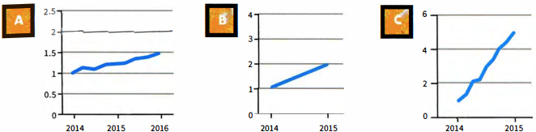
 | Complete the table using the adverbs from the box. | TIP 11
  11
  considerably | consistently | sharply | gradually | moderately
  substantially | dramatically | slowly | rapidly
  Big change | Small change | Gradual change | Quick change
  significantly  considerably  dramatically  substantially | slightly  moderately | steadily  gradually  slowly  consistently | quickly  sharply  rapidly
  Make sure you know how to spell these adverbs correctly as it is common for students to make errors with them.
 | Complete the sentences using the adverbs from exercise 11 and following the prompts in the brackets. More than one answer may be possible.  - Home ownership has decreased significantly / considerably / substantially / dramatically (big) over the last five years.  - Property prices have increased slightly / moderately (small) over the last six months.  - The property market is growing gradually / steadily / slowly / consistently(gradual) in this area.  - Interest rates have increased sharply / quickly / rapidly (quick) recently.
  12

[[[[[[[[[PART 1: DESCRIBING TRENDS]
 | Look at the trends illustrated by the graphs and charts. Discuss them with a partner using the language you have learnt in this lesson.
  13
  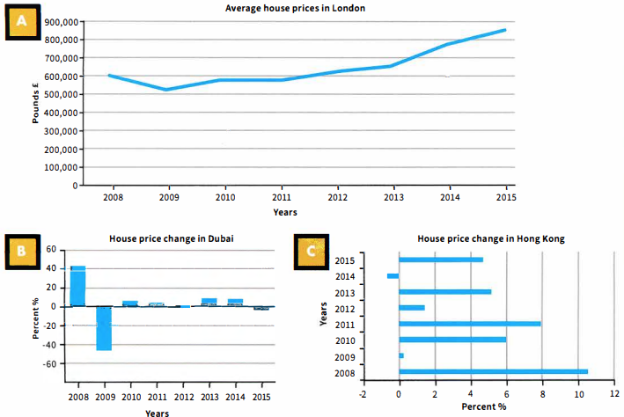
 | Match descriptions 1-3 with the graphs and charts A-C, then complete the first gap in each sentence with the correct country name.  - Since 2008, house prices in B Dubai have fluctuated heavily. In 2008 prices went up by just over 40% and then plummeted dramatically to-40%.  - Since 2008, house price increases in C Hong Kong have remained under 11% each year. In 2008 prices reached a peak, with a rise of just over 10%.  - Since 2010, house prices in A London have increased steadily. In 2009, prices decreased substantially, by almost £100,000, but went up again rapidly in 2010 to approximately £600,000.
  14
 | Complete the sentences in exercise 14 using the words and phrases in the box.
  15
  decreased substantially | increased steadily | remained | peak | rise
  plummeted dramatically | went up | fluctuated | went up

[[[[[[[[[EXAM SKILLS]
 | Use the information and language from this lesson to answer this Writing Part 1 task. You should spend about 20 minutes on this task.  The chart below gives information about how people aged 25-34 are housed in the UK.  Summarise the information by selecting and reporting on the main features, and make comparisons where relevant.  Write at least 150 words.  Sample answer  The bar chart shows how many people aged 25-34 either rent or have bought a house in the UK. Furthermore, it illustrates this change over an eleven-year period.  The number of home owners within this age range has decreased substantially since 2004. In 2004, nearly 60% owned their own home, whereas in 2014 this dropped to under 40%. There was a gradual decrease in home ownership over the eleven-year period which was more significant from 2009 to 2014. Only in 2011 and 2012 did the number remain stable at just over 40%.  The rental market, however, has increased dramatically over the same eleven-year period. From 2004 to 2014, the number of people renting has risen by nearly 30%. Again, this has been a gradual increase in most years, rising by just a few percent each year. In 2014, the rental market reached a peak at just under 50%.  In conclusion, therefore, it is easily apparent from this bar chart that for people between the ages of 25 and 34, the rental market is increasing each year, whereas the buyers' market is decreasing. | TIP 16  TIP 16
  16
  How people aged 25-34 are housed in the UK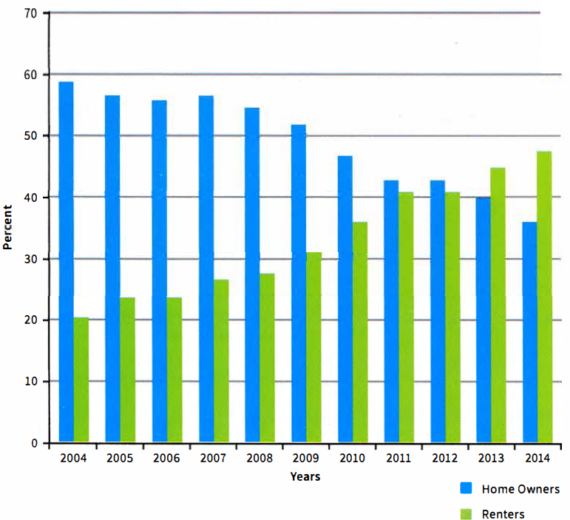
  Do not give your opinion, just the facts.
  Remember to include an introduction and conclusion in your answer.

UNIT/01: THE MAN-MADE ENVIRONMENT

LISTENING
IN THIS unIT YOU WILL
LEARN HOW TO
- predict the type of information required for short-answer questions
- listen for specific information (e.g. complex numbers, difficult spellings) and write it down correctly
- listen to understand context
- answer multiple-choice questions correctly by eliminating distractors.

Lead-in
 | Listen to an estate agent describing the three properties in the pictures and write the correct number in each box.  02  - C  - B  - A
  01
  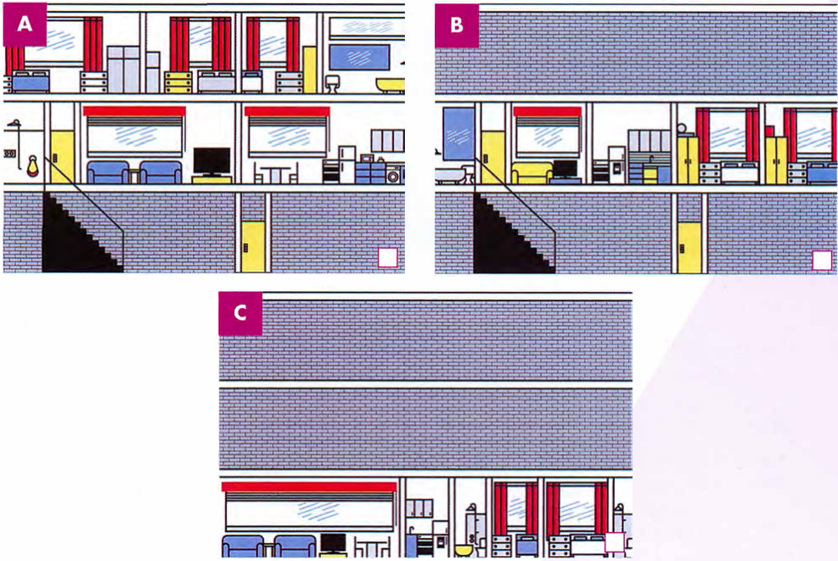
 | Listen again and note down the words which helped you find the answers.  02  - ground floor, two-bedroom  - first floor, two double bedrooms, one bathroom  - two levels, large double bedroom, smaller double, third bedroom, spacious living room, large kitchen/dining room
  02

LISTENING FOR SPECIFIC INFORMATION

 | Look at these notes and think about the kind of information that you will need for each gap, e.g. an address or telephone number. Then listen to the recording and complete the notes with NO MORE THAN TWO WORDS AND/OR A NUMBER.  03 | TIP 03
  03
  Address of property 1 Churchill Road
  Number of bedrooms 2 Three / 3
  Number of lounges 3 Two / 2
  Access to the 4 garden through sun-room door
  Kitchen: fully-fitted, includes 5 (a) cooker and 6 (a) dishwasher
  Appointment time: 7 1 / one o’clock
  Estate agent's name: Peter 8 Eliot
  Estate agent's number: 9 0786 39 05073
  In the Listening test, you will be given the context of the listening and you will have some time to look at the questions before you listen.
 | In the Listening test you may be asked to write down numbers, such as prices and phone numbers. Listen to these short conversations and write down the numbers in each.  04  - £53.72  - 472 km  - 01897625730  - 110 m x 55m  B1074
  04
 | In this exercise, you will hear some complex numbers, including a price and measurements. Listen to the estate agent and client and complete the information sheet.  05
  05
  Property for sale
  Price | 1 £350,000
  Room sizez | Kitchen: 3.1 * 2.25m  Lounge 1:2 4.3 x 3.28 m  Lounge 2: 6.5 * 4.25m  Front garden: 10 * 8m  Rear garden: 3 30 x 10 m, patio, lawn and flower beds  Bedroom 1: 4 4. 91 x 3.95 m  Bedroom 2:5 4.2 x 3.55 m  Bedroom 3:3.25 * 2.5m

 | Listen to the final conversation between the estate agent and client and answer these questions.  06  - What information does the estate agent need?  name, address and home phone number  - How will the client get the money to pay for the house?  mortgage from bank and deposit in bank account  - How long does the estate agent think it will take to sell the house?  two months (three at the most)  - The most important thing for the client is  C (she wants to move in before her children start school)  - to stay a little longer where she is living now.  - to help her husband travel to work more easily.  - to move in before the end of the school holiday.
  06

DEALING WITH DISTRACTORS

 | Look at this example and listen to part of the recording again.  07  The en-suite bathroom will be useful because  - it has a shower unit.  - it has a big bath.  - it helps everyone in the mornings.  Answer C is correct. A is true, but it is not the reason why it will be useful for the woman and her family. B is not true, because the other bathroom has a bath. C is correct because the speaker says that it will be useful when they all get up to get ready for school or work - and that happens in the morning.
  07
  ◉ In multiple-choice questions in the Listening test, there is one correct answer and two wrong answers. The wrong answers are called 'distractors'. They are designed to seem correct. For example, they use the same words as the recording, but with a different meaning. You have to make sure that the correct answer has the same meaning as the recording.

[[[[[[[[[[EXAM SKILLS]

 | Listen to the final conversation again and choose the correct letter, A, B or C.  06  - 1 At the moment, Caroline lives in  B  - Prendergast Road.  - Lanchester Road.  - Riverside Road.  - Caroline wants to make a first offer of  C  - £300,000.  - £350,000.  - £340,000.  - Caroline and her family  A  - have sold their house.  - are selling their house now.  - will sell their house in two months' time.  - It may take longer to sell the house if  B  - the bank does not check the house quickly.  - there are plans to do some building near the house.  - her husband has problems at work.  - If the sellers do not accept her first offer, Caroline will need to  A  - increase her offer.  - come to an agreement in a week.  - contact her bank and ask for more money. | TIP 08  TIP 08
  08
  Remember that you need to focus on the meaning of the distractors.
  To arrive at the correct answer, listen for synonyms and similar expressions, or for the same ideas expressed in a different way to the recording.

UNIT/01: THE MAN-MADE ENVIRONMENT

SPEAKING
IN THIS unIT YOU WILL
LEARN HOW TO
- speak about various aspects of where you live for Speaking Part 1
- respond to wh-, would and Yes/No questions about where you live
- prepare more information for common Speaking Part 1 topics
- use syllable stress in words correctly.

Lead-in

 | In Part 1 of the Speaking test, you may be asked about your home town. Organise the words into things you like in your home town, things you don't like and things you would like to have, if they are not already in your home town.
  01
  Things I like | Things I don’t like | Things I wish I had in my home town

 | Listen to an extract from Speaking Part 1 and answer these questions. Discuss your answers with a partner.  08  - How many questions did the examiner ask?  Eight / 8 questions  - What kind of questions did the examiner ask? What were the question words?  Wh-questions - Where, Who, When, Why; Would questions;  Yes/No questions with Is and Do  - What two topics did the examiner cover?  where (you) live; shopping  - Approximately how long did the student speak for each question? How many sentences did they use?  Approximately 15-20 seconds; 3-4 sentences per question | TIP 02
  02
  The Why? question usually comes last, and might be more difficult to answer.
  Try to explain clearly, but don't go into too much detail at this stage.

RESPONDING TO WH- QUESTIONS

◉ Most Speaking Part 1 questions are Wh-questions. These include What?, Who?, When?, Where? and Why?

 | Listen again to the recording from exercise 2. Note down useful language the student uses.  08
  03
  Home | Shopping
  pretty big house  two floors, garden, shared bathroom  city centre  about five minutes' walk  a 20-minute bus ride  I'm (pretty) happy with the location  Well  I don't like  shared house  the trains can be a little loud | shopping centre  cinema  ice-rink  hang out  famous brands  gets very full  everything is in one place  clean and comfortable  entertainment  under one roof  local market  styles and brands  old-fashioned
 | With a partner, ask and answer these questions.  Your home town  - Where do you come from?  - What is the weather like in your home town?  - When is the best time of year to visit your home town?  - Why do you like/not like your home town?  Your accommodation  - Where are you living now?  - Who else do you live with?  - What is your favourite room in your home?  - Why do you like/not like the place where you live?
  04
 | Some questions ask you to think about something you might do, using 'would'.  Ask and answer these questions with a partner.  - Would you recommend your house/apartment to another person?  - Would you move house if you had the chance?  - Would you like to buy a house in your home town one day?  - Would you like to live by yourself or with family/friends?
  05

THINKING OF MORE INFORMATION

 | These words are useful when talking about your home town.  Write four sentences about each, using prompts 1-4.  - People in my home town usually/don't often go out at night because __.  - My favourite thing about my home town is the culture because __.  - A famous historical place in my home town is __.  - I like/don't like the weather in my home town because __.
  06
  culture | historical | monument | museums | nightlife
  parks | restaurants | shopping | weather
  ◉ There are a number of possible topics you might be asked about in Speaking Part 1, such as the news, entertainment or sport. To prepare for this, you need to know some basic information about each topic.

RESPONDING TO YES/NO QUESTIONS

◉ Other types of question ask for a Yes/No response.
These questions usually start with Do(es) or Is/Are.

 | Match questions 1-6 with answers a-f.  - Do you live near the sea? b  - Is there anything you don't like about where you live? d  - Is your house in the city or the countryside? a  - Do you live in a house or an apartment? f  - Is there anything special you can do in your home town? c  - Are there any interesting places to visit in your home town? e  - We live in the suburbs, just outside the city, about 20 minutes' drive by car.  - Yes, we live on the coast, and we can see the beach from our window -it's pretty nice.  - Not really, I think my home town is a little boring. We mostly take a train to Shanghai when we want to do something.  - Yes, the weather there is pretty terrible. We only get about six weeks of summer, and it's very cold most of the time.  - Yes, there are many monuments and museums to see - we have a lot of culture and history.  - We currently live in a small apartment on the 33rd floor. My last house was much bigger... | TIP 07
  07
  It is not enough to just say Yes/No. Try to add at least two sentences with extra information, explaining your answer.
 | Ask and answer these questions about your home town/accommodation.  Your home town  - Do you live in the city or the countryside?  - Do you live near the sea?  - Is there anything special that people do in your home town?  - Are there any interesting places to visit in your home town?  Your accommodation  - Do you live in a house or an apartment?  - Is your house in the city or the countryside?  - Do other people live with you?  - Is there anything you don't like about where you live?
  08

THINKING OF NEW IDEAS

 | Try to write FOUR questions (either Wh-? or Yes/No questions) for each topic in the mindmap. Ask and answer questions with a partner.
  09
  Weather  Do you like the weather in your home town?  When was the last time it was really cold in your home town?  Does it ever snow in your home town?  When is the best time of year to visit your home town? |  | Shopping  _________________  _________________  _________________
  Culture  _________________  _________________  _________________ | Monument  _________________  _________________  _________________ |  | Restaurants  _________________  _________________  _________________
  Nightlife  _________________  _________________  _________________ | Museums  _________________  _________________  _________________ |  | Parks  _________________  _________________  _________________
  ◉ You may be asked about a topic you know well, but the exact question could be unfamiliar. It can be useful to make your own questions for a topic to explore new ideas you have not thought about before.
 | Add TWO more topics to the mindmap.  Other topics: sport, healthcare
  10

SYLLABLE STRESS

 | Listen to the sentences. Underline the stressed syllable in the words.  Right now, I am living in an apartment with my friends.  09
  11
  - a/part/ment  - ac/comm/o/da/tion  ac/comm/o/da/tion  - ar/chi/tec/ture  ar/chi/tec/ture  - con/struc/tion  con/struc/tion | - es/ca/la/tors  es/ca/la/tors  - in/ha/bi/tants  in/ha/bi/tants  - mon/u/ment  mon/u/ment  - mu/se/um  mu/se/um | - res/i/den/tial  res/i/den/tial  - sta/di/um  sta/di/um  - coun/try/side  coun/try/side  - en/vi/ron/ment  en/vi/ron/ment | - ge/og/ra/phy  ge/og/ra/phy  - re/gion/al  re/gion/al  - temp/er/a/tures  temp/er/a/tures  - sce/ne/ry  sce/ne/ry
 | Listen to the words again and repeat them with the correct syllable stress.  10
  12
[[[[[[[[[[EXAM SKILLS]
 | Answer these questions about accommodation and your home town.  Reply with THREE SENTENCES ONLY for each question.  - Where do you come from?  - Are there any special places that tourists visit in your home town?  - When is the best time of year to visit your home town?  - Why do you like / don't you like your home town?  - Where are you living now - in a house or an apartment?  - Does anyone else live with you?  - What is your favourite room where you live?  - Would you recommend your accommodation to another person?
  13

UNIT/02: LEISURE AND RECREATION

READING
IN THIS unIT YOU WILL
LEARN HOW TO
- identify questions which ask for factual information and questions which ask for the writer's opinion
- skim and scan to arrive at the correct answers quickly
- understand the whole text to answer questions about global understanding
- use the past simple and past continuous correctly.

Lead-in

 | A common topic in the exam is 'home'. Put these words under the correct heading in the table.  - Muhammad Ali  - Michael Jordan  - Serena Williams  - David Beckham  - Jack Nicklaus
  01
  Serena Williams | Jack Nicklaus | David Beckham
  Muhammad Ali | Michael Jordan
  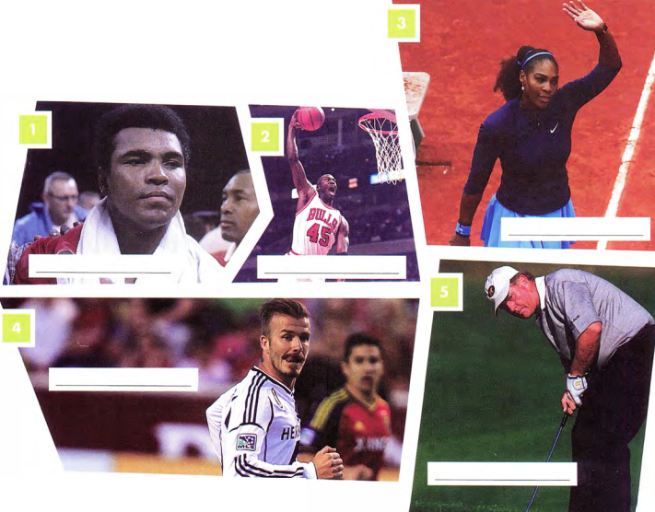
 | Which sport are/were these people famous for?  - Boxing  - Basketball  - Tennis  - Football  - 5 Golf
  02

 | With a partner, try and answer the multiple-choice quiz. What else do you know about these sports stars?  SPORTING LEGENDS
  03
  1  In what year did Serena Williams first become World Number 1? B | 4  How long was David Beckham captain of the England team? C
    - 1995 | - 2002 | - 2007
    - 3 years | - 10 years | - 6 years
  2  How many major championships did Jack Nicklaus win during his career? A | 5  How tall is Michael Jordan? A
    - 18 | - 21 | - 12
    - 1.98 m | - 1.70 m | - 1.82 m
  3
  How old was Muhammad Ali when he started training? B
  - 21 | - 12 | - 8
  ◉ In the Reading test you may be presented with this type of multiple-choice question. The answers, however, will all be located in the text and will not test your general knowledge on any subject.

[[[[[[[[[[FACTS AND OPINIONS]
◉ There are two types of question:
- those which ask for factual information
- those which ask for the writer's opinion.

 | Read these paragraphs and answer the questions which follow.  Choose the correct letter, A, B or C.  - Why does the writer think that Muhammad Ali is still considered a legend?  B  - because he is a successful athlete  - because of several factors, not just his abilities as a boxer  - because he has great appeal  - What name did Muhammad Ali give himself during his career?  B  - Cassius Clay  - The Greatest  - The Champion | TIP 04
  04
  WHY IS THE FORMER BOXER MUHAMMAD ALI
  STILL CONSIDERED A LEGEND?
  Although Muhammad Ali was responsible for many legendary moments in the boxing ring, there was much more to this man's appeal. Not only was he a successful athlete, but he was also well known for his strong work ethic and fearless approach to standing up for his beliefs. | Born as Cassius Clay in 1942, Muhammad Ali began training at just 12 years old and, at the age of 22, won the world heavyweight championship in 1964. It was a title he went on to win again, in 1974 and 1978. He referred to himself as 'The Greatest', and was famous for boasting about his ability to 'float like a butterfly and sting like a bee'.
  The answers are in the same order as the text.

 | Now answer these questions.  - Which question is factual and which asks for the writer's opinion?  1: opinion 2: factual  - Look at question 1 again. Are all the answers possible? Why did you choose one particular answer?  yes, most appropriate answer chosen  - Do any of the words in the first paragraph match the words in question 1?  Do matching words give you the correct answer?  yes, appeal, successful athlete; no, matching words are often misleading  - What phrase is used to mean 'give himself the name' in the second paragraph?  reffered to himself as
  05

APPROACHING THE QUESTION

◉ In the Reading test, the texts are much longer than in exercise 4, so it is important to develop a strategy which allows you to get the correct answer quickly.

 | Complete the flow-chart showing one approach with words from the box.
  06
  instructions | understand | key | questions | scan | wrong
  Read the 1 questions and instructions carefully. | → | Read the text to 2 understand the general meaning. | → | Read the questions again and underline 3 key words, e.g dates, names etc. | → | 4 Scan the text for the key words or synonyms. | → | Read around the key words in the text. | → | Re-read the questions and choose an answer. | → | Quickly check the other options are 5 wrong and make your final choices.
 | Use this approach to answer questions about the text. Choose TWO letters, A-D.  - According to the writer, Serena has become so famous because...  B, D  - she is aggressive.  - she has a strong tennis game.  - she is very good at fashion.  - she has self-belief.  - During Serena's upbringing, what did her father consider to be important?  B, C  - staying at home  - tennis training  - her studies  - training her to be a star  - Her tennis game is so successful because...  A, B  - she thinks quickly.  - she can hit the ball hard.  - she is the third fastest player in the world.  - her opponents are nervous of her. | TIP 07
  07
  Serena Williams has dominated women's professional tennis since the late 1990s, when she and her sister, Venus, became global tennis superstars. Serena in particular has become known for her determination, powerful game and unique fashion sense.  Serena was born on 26 September 1981 in Saginaw, Michigan. When she was just a baby, her family moved to California, and it was there she started playing tennis at the age of four. She was coached by her father, Richard Williams, until she was 12. Although Mr Williams was determined that his daughters would succeed in the tennis world, he was also focused on giving them a good education. | In fact, whilst they were training to be tennis stars, he also took responsibility for their home-schooling.  Serena is so successful on the tennis court because of her rapid movement, speed of thought and powerful shots. Indeed, whilst she was playing a match in the 2013 Australian Open, Serena hit a serve" at a speed of just under 207 km per hour, the third fastest recorded among female players. This powerful serve helps put her opponents under pressure from the very start of the game.  During her career, she has won 56 singles championships, 22 doubles championships and was also a gold medallist at the 2000, 2008 and 2012 Olympics.  *to serve (v)- to hit the ball to the other player as a way of starting the game
  It is important to read the instructions very carefully as the number of letters you need to choose can vary.

 | Answer these questions.  - Which questions ask you to complete the sentence and which ask you to answer the question?  Complete: 1,3 Question: 2  - How many synonyms from words in the text are used in the questions?  - Text: powerful, Question: strong; Text: determination, Question: self-belief  - Text: be important, Question: focused on; Text: training to be tennis stars, Question: tennis training; Text: education, Question: studies  - Text: speed of thought, Question: thinks quickly; Text: powerful shots, Question: can hit the ball hard  - Do any answers match the wording in the text?  - Answers: fashion, Text: fashion  - Answers: home, Text: home; Answers: training, Text: training; Answers: star, Text: star  - Answers: hit, Text: hit; Answers: third fastest, Text: third fastest; Answers: opponents, Text: opponents  - Are these answers the correct ones?  In questions 1 and 2, no, the same words are not used in the text and the correct answers. In question 3, both the text and one of the correct answers use the word hit. | TIP 08
  08
  The topic sentence is often, but not always, the first sentence in a paragraph, so that is the first place to look.

GRAMMAR FOCUS: PAST SIMPLE / PAST CONTINUOUS

◉ You will not be given any grammar exercises in IELTS. However, it is important that you can recognise which tenses are used and what they mean.

 | Say which past tenses are used in the text.  past simple, past continuous, present perfect
  09
 | Study this sentence, then answer the questions.  ... whilst she was playing a match in the 2013 Australian Open, Serena hit a serve at a speed of just under 207 km per hour...  - Underline the two past tenses in the sentence.  she was playing..., Serena hit...  - Which actions (verbs) were happening in the past at the same time?  playing a match / hitting a serve  - Which is the long, continued action? Which is the short, finished action?  Long, continued action: playing a match; short, finished action: hit a serve  - Are both actions finished now?  yes
  10
 | Study this diagram and answer the questions which follow.  - Are there any other examples of the past continuous in the text?  - Complete this rule:  When we use the simple past and the past continuous in the same sentence, we use the whilst they were training to talk about the 'background action' and the past continuous, past simple to talk about the shorter, completed action.
  11
  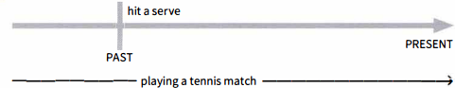
 | Complete the sentences by putting the verb in brackets in the correct form of the past continuous or past simple.  - Whilst she was playing(play) basketball, her phone rang(ring).  - He fell(fall), while (he was) running(run) for the ball.  - It started(start) to rain in the middle of the race.  - It was raining(rain) during the race.
  12
 | Complete the sentences with your own ideas.  - Whilst Michael Jordan was running down the court, he threw the ball to his opponent.  - David Beckham injured his knee whilst he was scoring a goal.  - Jack Nicklaus was taking a shot when he heard a loud noise.
  13

[[[[[[[[[[GLOBAL UNDERSTANDING]
 | This section focuses on questions which check your understanding of the text as a whole. Read the text and choose the correct letter, A, B or C.  Despite Beckham's good looks and famous marriage to Victoria Beckham, he was actually an exceptionally good footballer. His professional career began with Manchester United in 1992, at the age of 17. With United he won the Premier League title six times, the FA Cup twice and the UEFA Champions League in 1999. He later went on to play for Real Madrid and LA Galaxy.  In international football, he made his England debut in 1996 at the age of 21.  He was also made captain in 2002 and had short spells at AC Milan and Paris St Germain. His former boss, Alex Ferguson, praised David for always trying hard, playing with supreme confidence and scoring important goals  His football career was not always easy, however. During the 1998 World Cup, in a game against Argentina, he was fouled by the player Diego Simeone. In retaliation, Beckham kicked Simeone and was given a red card. Consequently, when England went on to lose the game and go out of the World Cup, Beckham became hated by football fans and was portrayed very negatively by the media.  It took three years before Beckham was allowed to play for England again and in 2002 he redeemed himself by scoring a penalty in a 1-0 victory against Argentina.  In 2013 Beckham retired from professional football and played the last game of his 20-year career. Although he is now retired from football, reports claim that he earns more money now than he did as a successful footballer, In 2014 it was documented that he earned £50.5 million, a large portion of which came from brand endorsements for companies such as Adidas, Sky Sports and Samsung.  What is the best title for this article?  B  - What has Beckham achieved during his career?  - Despite all the media attention, was Beckham a good football player?  - What problems did Beckham have during his football career? | TIP 14
  14
  For this question type, do not choose an answer based just on one paragraph. You need to read the whole text in order to choose the correct summary.

[[[[[[[[[[EXAM SKILLS]
 | Using all the skills you have learnt in this lesson, read the text and complete the multiple-choice task which follows.  Choose the correct letter, A, B or C.
  15
  A BRIEF HISTORY OF FOOTBALL
  There is no clear evidence stating where and when football was actually invented, but most historians agree that some type of ball game had been played centuries before the modern game developed in England. Football has a long and interesting history and origins of the game are present in sports played thousands of years ago in China, Egypt, Japan and Greece. Aspects of the game can be traced as early as the second and third centuries BC in China. Their game, originally named 'Tsu Chu', involved kicking a leather ball into a small hole.  The first football games played in Britain were in the 700s and the English equivalent of a football was made using an animal bladder. Games were violent and injury and death were common. Despite the violence, however, they were still very popular. The game had become so popular that in the 1300s Edward II banned the sport because people were playing football rather than practising archery. This was especially important to this king, as he was preparing to go to war with Scotland. This was to be the first of many bans imposed by the kings and queens of England. | In 1605 football became legal and once again the sport grew in popularity.  In the 1800s it became particularly common in private schools such as Eton, and it was only then that a set of rules was established. Until then, the game had continued to be violent, as it had had limited rules and no referees. Before the 1800s, for example, it was considered normal to hit players on the opposite team and to damage their possessions. In 1848, on Parker's Piece in Cambridge, these rules were developed further and a new version called the 'Cambridge Rules' was used by all schools, colleges and universities.  Though football could be considered a male sport, women also play it.  An increase in women playing the sport began during the First World War, when women did jobs traditionally done by men. Those working in places like factories regularly met to play. Unfortunately, a ban was imposed when the war ended, but it was eventually lifted in the UK in 1971. In 1991 China hosted the first Women's World Cup and in 1996 the first ever women's football event was held at the Olympics.
  - Where can the first traces of football be found?  B  - Egypt  - China  - England  - Why did Edward II ban football in the 1300s?  C  - because it was too violent and death was common  - because he was preparing to go to war with China  - because people weren't practising archery | - Before rules were established in the 1800s, which of these activities was considered normal?  B  - stealing from opponents  - destroying players' property  - being violent towards the referee  - Women started playing football because  B  - the ban was lifted in 1971.  - they started to work during the First World War.  - in 1991 there was the first Women's World Cup.

UNIT/02: LEISURE AND RECREATION

WRITING
IN THIS unIT YOU WILL
LEARN HOW TO
- select and compare key features of charts, graphs and tables
- structure an answer which compares information from charts, graphs and tables
- revise the form and use of comparatives.

Lead-in

 | Discuss these questions with a partner.  - Have you ever watched the Olympic Games, either live or on television? If so, which sports did you enjoy watching the most?  - Do you prefer the winter or summer Olympics? Give reasons for your answers.
  01
 | Study the chart and graph and answer the questions which follow.  - Which countries (or former countries) were successful in both the winter and summer Olympics?  USA, USSR and Germany  - Which country (or former country) won the most gold medals in the winter Olympics?  Norway  - Which country (or former country) won the fewest medals in the summer Olympics?  France
  02
  Winter Olympics - highest ranking medal  winners of all time  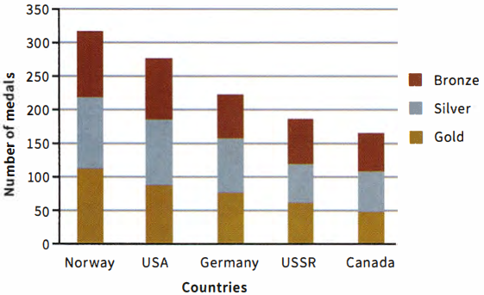 | Summer Olympics - highest ranking  medal winners of all time  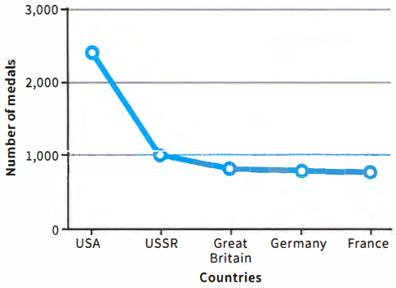

STRUCTURING YOUR ANSWER

 | Read this sample answer, which describes the chart and graph in exercise 2.  MODEL ANSWER
  03
  The bar chart shows which countries have won the most medals in the winter Olympics. It also states how many gold, silver and bronze medals each country has achieved. In contrast, the line graph shows which nations have won the most medals in the summer Olympics.
  Overall, the bar chart shows that in the winter Olympics, Norway has gained the most medals, winning an equal number of gold, silver and bronze medals. It has won just over three hundred medals, whereas Canada, in fifth place, has won approximately 150 medals.
  The results of the summer Olympics are quite different, however, with the USA having won the most medals. Overall, the USA has won just under 2,500 medals, a much higher number than the other four countries on the graph. The USSR is the second highest, winning approximately a thousand medals.
  To summarise, the bar chart and the graph illustrate how many medals the highest-ranking countries have won in the summer and winter Olympics. The results of each Olympics are very different, with the USA, the USSR and Germany being successful in both.
 | Label the paragraphs of the sample answer 'Summary', 'Main body' or 'Introduction'.  - Introduction  - Main body  - Main body  - Summary
  04
  ◉ The sample answer describes a graph and a chart, as you may be asked to do in the Writing test.
  Although this may look difficult, the structure is similar to describing just one graph.
 | Answer these questions, which deal with some minor differences between discussing one graph and comparing two or more graphs.  - Did the writer introduce both graphs in the introduction?  yes  - Did the writer discuss the details (main body) of both graphs in the same paragraph or separate paragraphs?  separate  - Did the summary include both the bar chart and the graph or just one?  both
  05
 | Complete the gaps with 'main body', 'summary' or 'introduction'.  The 1 Introduction should state what the graph is about. Do not copy the wording of the question. You should paraphrase the question using synonyms, e.g. illustrates / shows.  The 2 Main body should discuss the general trends in the graph, supported by the relevant data, e.g. dates or numbers. Identify the most important features - do not try to include everything.  The 3 Summary should provide an overview of the key points made in the 'Main body'. Do not include new information or your own opinion. | TIP 06
  06
  Sentences should be simple and easy to understand, not long and complicated.

 | Study these two charts.
  07
  Country medal leaders of all time_ Badminton  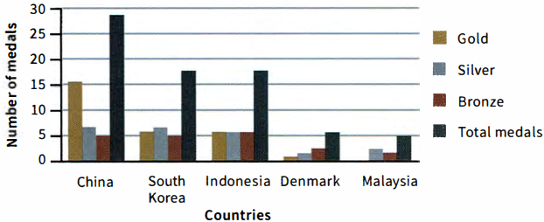 | Country medal leaders of all time - Rowing  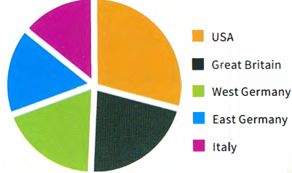
 | Read and order the sample answer describing the two charts.  1: C 2: A 3: D 4: B  MODEL ANSWER
  08
  A
  Looking at the bar chart it is easily apparent that China has been significantly more successful than any other country in badminton. They have achieved far more gold medals than other countries but have gained only slightly more silver and bronze medals.
  B
  To summarise therefore, both charts illustrate the countries (or former countries) with the greatest number of medals. The bar chart indicates that China is the most successful country in badminton and the pie chart shows that the USA is the most successful in rowing.
  C
  The bar chart illustrates the country medal leaders in badminton and also the number of gold, silver and bronze medals won by each country. The pie chart, however, shows which countries are the most successful in rowing.
  D
  The pie chart, on the other hand, shows that the USA won the most medals in rowing. They were a little more successful than Great Britain, however. The other three countries represented won roughly the same number of medals each.

GRAMMAR FOCUS: COMPARATIVES

 | Read this sentence from the sample answer and underline the comparative form.  (significantly) more successful than  Looking at the bar chart it is easily apparent that China has been significantly more successful than any other country in badminton.
  09
  ◉ Comparative forms are often needed when comparing data, either in one graph or two, so it is important to become familiar with their structure.
 | Underline all the comparative forms in the sample answer.  achieved far more gold medals, slightly more silver and bronze medals, a little more successful than Great Britain, the same number of medals
  10

 | Complete the sentences with the correct comparative form of an adjective or adverb from the box.  - In the triathlon he swam much slower/more slowly than he cycled.  - In the ski-jumping event, participants were required to go much further/farther than ever before.  - Generally, countries with a colder climate are more successful in the Winter Olympics.  - Spectators found this ice-hockey game more interesting than the last one.  - He ran well: better than last year.  - Before the Games she practiced more often than her team mates.  - The oldest recorded male medallist was 72 years old, making him 62 years older than the youngest-ever medallist.  - He accepted defeat with grace: more gracefully than the rest of his team.
  11
  cold | far | gracefully | interesting | often | old | show | successful | well
 | The sample answer includes the sentence 'China has been significantly more successful than any other country in badminton.' What other modifiers are used in the answer?  easily (apparent), far (more), slightly (more), a little (more), roughly (the same)
  12
  ◉ In this sentence from the sample answer the word significantly is used to modify the comparative. In other words, to say how big or small the comparison is. Here, the word significantly is called a 'modifier'.

COMPARING DATA: CHOOSING THE RELEVANT INFORMATION

 | Study this table and graph, then answer the question which follows.
  13
  Top medal winners of all time - athletes
  Athlete | Country | Sport | Total
  Michael Phelps | USA | Swimming | 22
  Larysa Latynina | USSR | Gymnastics | 18
  Nikolai Andrianov | USSR | Gymnastics | 15
  Ole Einar Bjoerndalen | Norway | Biathlon | 13
  Borys Shakhlin | USSR | Gymnastics | 13
  Medals won in all Olympics
  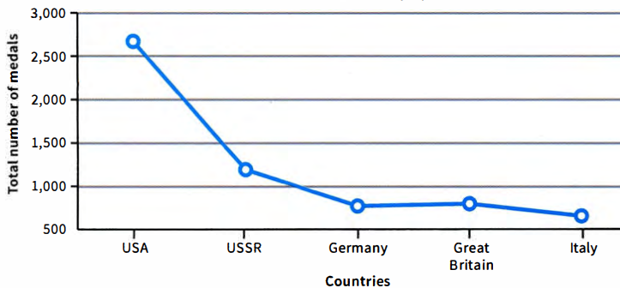

Which of this information would you include in your answer?
1,2,5
3 and 4 just describe facts taken directly from the table (i. e. no interpretation has taken place)
- The most successful athlete is Michael Phelps from the USA, who has won the most medals for swimming.
- The chart also shows that three of the top five athletes were gymnasts from the USSR.
- Michael Phelps won 22 medals, Larysa Latynina 18, Nikolai Andrianov 15, Ole Einar Bjoerndalen 13 and Borys Shakhlin 13.
- The sports which the athletes achieved medals in were swimming, gymnastics and the biathlon.
- In summary, both charts illustrate that the two most successful countries in the Olympics were the USA and the USSR.
 | Now, study the line graph again and write three statements similar to those in exercise 13.  Possible answers  - The most successful country is the USA, which has won over 2,500 medals.  - The line graph shows that Germany and Great Britain have won a similar number of medals.  - The second most successful country is the USSR, which has won fewer than half the medals of the USA. | TIP 13-14
  14
  Try to group important information together.
[[[[[[[[[EXAM SKILLS]
 | Use the information and language from this lesson to answer this Writing Part 1 task. You should spend about 20 minutes on this task.  The chart and graph below give information about participants who have entered the Olympics since it began.  Summarise the information by selecting and reporting on the main features, and make comparisons where relevant.  Write at least 150 words.  Sample answer  The two charts give information about the gender and number of athletes who have entered the Games since they started. The bar chart illustrates the number of men and women entering the Games, whereas the line graph shows the number of participants.  It is evident from the bar chart that, until 2012, there were always significantly more men entering the Games than women. In 1924 and 1952, there were hardly any women entering the Games, yet in 1952 there were over 4,000 male participants. In 2012, however, the number of female athletes rose significantly to nearly 5,000, only approximately 1,000 fewer than male participants.  The line graph shows a similar trend, with the number of participants increasing throughout the century. The most significant increase occurred between 1984 and 2012, when the number of athletes rose from just over 6,000 to over 10,000 in 2012.  To summarise therefore, since 1924 the number of athletes entering the Olympic Games has increased dramatically. This is particularly the case for women, who are now represented in nearly the same numbers as male participants.
  15
  Number of male and female participants in the Olympics
  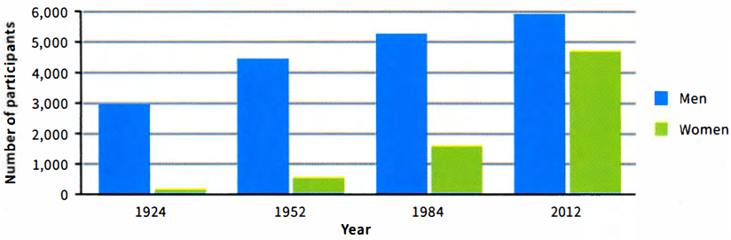
  Number of participants
  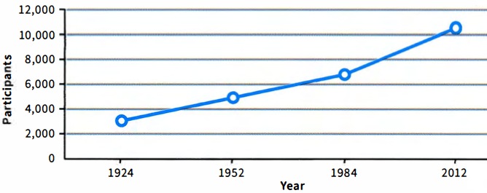

UNIT/02: LEISURE AND RECREATION

LISTENING
IN THIS unIT YOU WILL
LEARN HOW TO
- listen to and understand directions from one place to another
- match descriptions with people, places or things
- listen for specific information and classify it in a table.

Lead-in
 | Write the correct word under each diagram to check your understanding of language connected with road travel and directions.  - 1 crossroads  - junction  - bend  - flyover  - traffic lights  - roundabout
  01
  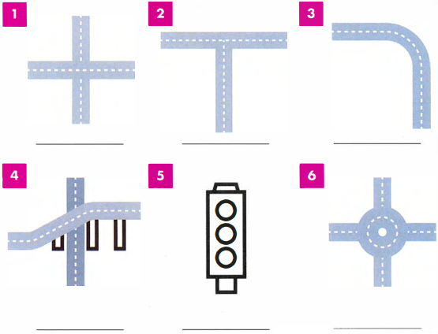

 | Listen to directions 1-6 and write the correct word from the box.  11  - Stay in the middle lane so that you can go over the motorway.  flyover  - You'll have to wait on the right till it changes for you to turn  traffic lights  - Go round and take the third exit on the right.  roundabout  - Slow down here because it goes to the left quite sharply.  bend  - When you get there, go straight across.  crossroads  - When you get to the end of this road, take the left turn.  junction
  02
[[[[[[[[[[SENTENCE COMPLETION]

◉ Before listening to directions to complete a map, you should look at the map carefully and think about the type of information you need to identify each place on the map. When listening, you should focus on words and phrases that will help you find the information, for example turn left or go straight on. You need to follow the directions carefully and try to predict which information will come next.

 | Listen to the Director of Sports giving directions from one sports centre to another. Write the letters in the correct position on the map.  12
  03
  - roundabout  1 | - junction  4 | - traffic lights  6 | - crossroads  2 | - flyover  3 | - bend  5
  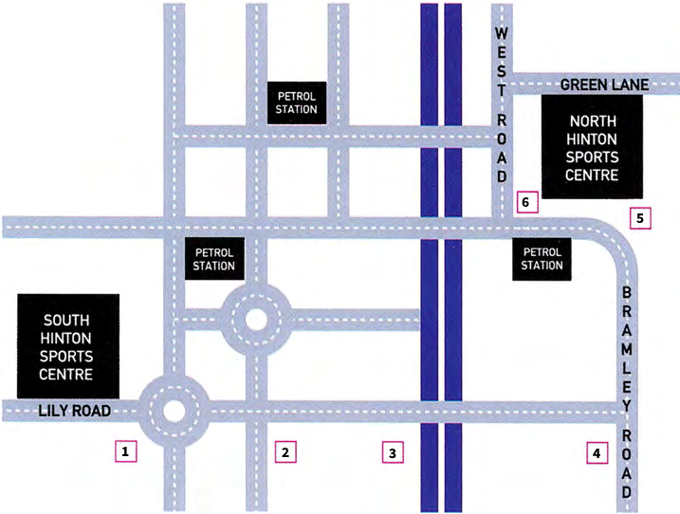
 | Listen to the descriptions of sports 1-5 and write the correct number next to each sport A-E.  13  - gymnastics - 2  - basketball - 5  - weightlifting - 4  - badminton - 1  - table tennis - 3
  04
  ◉ When matching descriptions to people, places or things, you need to focus on key words and ideas which can help you decide what is being described as well as what is not being described. For example, if you have to choose between football and cycling, a description with key words like goal, run and kick is more likely to describe football, and a description with ride, wheel and race is more likely to describe cycling.

 | Listen to the next part of the message. The Director of Sports is giving instructions for preparing three rooms for the inter-college sports competition at the sports centre. Write the sports in the correct gap in the table. One of the sports appearstwice.  14
  05
  badminton | basketball | gymnastics | table tennis | weightlifting
  North Hinton Sports Centre
   | Dean Room | Carsley Room | Forster Room
  Sport event - morning | - badminton | - gymnastics | - weightlifting
  Sport event - afternoon | - basketball | - table tennis | - weightlifting
[[[[[[[[[[EXAM SKILLS]
◉ In the Listening test you may need to complete categories in a table or set of notes which already has some of the information in place. You should look at the information in the table carefully to get a good idea of what other information is required. This will help you to focus on the missing information. For example, the word nets is already given under basketball, so you know that you will need to listen for another word connected with that category for question 2. In each case, you will hear the sport first, so you will be able focus on the missing word.

 | Listen to the last part of the message and complete the table with the pieces of equipment. Write ONE WORD ONLY in each gap.  15 | TIP 06
  06
  Sport event | basketball | gymnastics | table tennis | badminton | weightlifting
  Equipment | nets | vaulting horse | tables | 1: nets | barbells
   | 2: balls | 3: mats | nets | racquets | weights
   |  | 4: bars | 5: bats | shuttlecocks | 6: bench
   |  | rings |  |  | chalk
   |  | pommel horse
  You need to write the same words as you hear in the recording. You will be told how many words you need to write and you will hear the words in the same order they are given in the recording script.
 | The Director of Sports, Jeff, leaves another message for the three helpers, Steve, Amanda and Malik. In the message, he tells them who should be in charge of each event. Listen and write the correct organiser, A, B, C or D next to events 1-6.  16
  07
  - Steve  2  - Amanda  1, 6  - Malik  3, 4  - Jeff  5 | - badminton ___  - gymnastics ___  - weightlifting am ___  - basketball ___  - weightlifting pm ___  - table tennis ___

UNIT/02: LEISURE AND RECREATION

SPEAKING
IN THIS unIT YOU WILL
LEARN HOW TO
- express your opinions about sport for Speaking Parts 1 and 2
- use connecting words to give longer and more detailed answers
- use sentence stress and intonation to express your feelings about a topic.

Lead-in

 | Match the photos with the activities in the box.
  01
  football | gym | hiking | surfing the internet | video games
  movies | reading | swimming | karate / kickboxing
  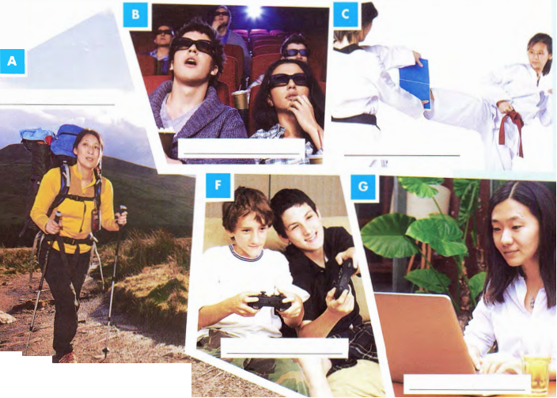
  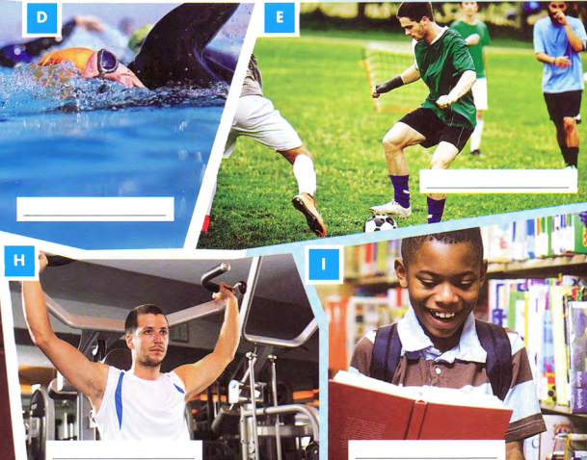

 | Work with a partner to ask and answer these questions.  - Do you like doing any of these activities in your spare time?  - Which activities do your friends like doing?  - Which of the activities are popular in your country?
  02

PARAPHRASING COMMON RESPONSES

 | Write the phrases in the box in the correct column of the table. | TIP 03
  03
  I like...  I'm not sure whether I like....  I often enjoy...  I'm not really interested in... | I don't know if I like...  I'm not a big fan of ...  I hate....  I don't look forward to... | A lot of people like...  I'm very keen on...  I don't know much about...  Not many people like...
   |  | 
  I like … | I don't know if l like... | I don't look forward to ...
  A lot of people like... | I'm not sure whether I like... | I hate....
  I'm very keen on .... | I don't know much about... | I'm not a big fan of...
  I often enjoy... | I'm not really interested in... | Not many people like...
  There are many ways to say you like or do not like something. Using a variety of phrases will improve your Speaking test score.

ADDING CONNECTING WORDS

 | Match sentence beginnings 1-4 with sentence endings a-d, using a suitable connecting word. There are several possible answers. | TIP 04
  04
  I love listening to K-Pop | AND | my friends don't really like it either.
  I sometimes enjoy mountain climbing | BUT | I prefer staying at home.
  I don't like spending money | SO | it's really exciting.
  I'm not really interested in watching football on TV | BECAUSE | I prefer watersports.
  Longer sentences will show the examiner that you can use more complex grammar.
 | With a partner, ask and answer these questions.  Your home town  - Where do you come from?  - What is the weather like in your home town?  - When is the best time of year to visit your home town?  - Why do you like/not like your home town?  Your accommodation  - Where are you living now?  - Who else do you live with?  - What is your favourite room in your home?  - Why do you like/not like the place where you live?
  04
 | Some questions ask you to think about something you might do, using 'would'.  Ask and answer these questions with a partner.  - Would you recommend your house/apartment to another person?  - Would you move house if you had the chance?  - Would you like to buy a house in your home town one day?  - Would you like to live by yourself or with family/friends?
  05

THINKING OF MORE INFORMATION

 | These words are useful when talking about your home town.  Write four sentences about each, using prompts 1-4.  - People in my home town usually/don't often go out at night because __.  - My favourite thing about my home town is the culture because __.  - A famous historical place in my home town is __.  - I like/don't like the weather in my home town because __.
  06
  culture | historical | monument | museums | nightlife
  parks | restaurants | shopping | weather
  ◉ There are a number of possible topics you might be asked about in Speaking Part 1, such as the news, entertainment or sport. To prepare for this, you need to know some basic information about each topic.

RESPONDING TO YES/NO QUESTIONS

◉ Other types of question ask for a Yes/No response.
These questions usually start with Do(es) or Is/Are.

 | Match questions 1-6 with answers a-f.  - Do you live near the sea? b  - Is there anything you don't like about where you live? d  - Is your house in the city or the countryside? a  - Do you live in a house or an apartment? f  - Is there anything special you can do in your home town? c  - Are there any interesting places to visit in your home town? e  - We live in the suburbs, just outside the city, about 20 minutes' drive by car.  - Yes, we live on the coast, and we can see the beach from our window -it's pretty nice.  - Not really, I think my home town is a little boring. We mostly take a train to Shanghai when we want to do something.  - Yes, the weather there is pretty terrible. We only get about six weeks of summer, and it's very cold most of the time.  - Yes, there are many monuments and museums to see - we have a lot of culture and history.  - We currently live in a small apartment on the 33rd floor. My last house was much bigger... | TIP 07
  07
  It is not enough to just say Yes/No. Try to add at least two sentences with extra information, explaining your answer.
 | Ask and answer these questions about your home town/accommodation.  Your home town  - Do you live in the city or the countryside?  - Do you live near the sea?  - Is there anything special that people do in your home town?  - Are there any interesting places to visit in your home town?  Your accommodation  - Do you live in a house or an apartment?  - Is your house in the city or the countryside?  - Do other people live with you?  - Is there anything you don't like about where you live?
  08

THINKING OF NEW IDEAS

 | Try to write FOUR questions (either Wh-? or Yes/No questions) for each topic in the mindmap. Ask and answer questions with a partner.
  09
  Weather  Do you like the weather in your home town?  When was the last time it was really cold in your home town?  Does it ever snow in your home town?  When is the best time of year to visit your home town? |  | Shopping  _________________  _________________  _________________
  Culture  _________________  _________________  _________________ | Monument  _________________  _________________  _________________ |  | Restaurants  _________________  _________________  _________________
  Nightlife  _________________  _________________  _________________ | Museums  _________________  _________________  _________________ |  | Parks  _________________  _________________  _________________
  ◉ You may be asked about a topic you know well, but the exact question could be unfamiliar. It can be useful to make your own questions for a topic to explore new ideas you have not thought about before.
 | Add TWO more topics to the mindmap.  Other topics: sport, healthcare
  10

SYLLABLE STRESS

 | Listen to the sentences. Underline the stressed syllable in the words.  Right now, I am living in an apartment with my friends.  09
  11
  - a/part/ment  - ac/comm/o/da/tion  ac/comm/o/da/tion  - ar/chi/tec/ture  ar/chi/tec/ture  - con/struc/tion  con/struc/tion | - es/ca/la/tors  es/ca/la/tors  - in/ha/bi/tants  in/ha/bi/tants  - mon/u/ment  mon/u/ment  - mu/se/um  mu/se/um | - res/i/den/tial  res/i/den/tial  - sta/di/um  sta/di/um  - coun/try/side  coun/try/side  - en/vi/ron/ment  en/vi/ron/ment | - ge/og/ra/phy  ge/og/ra/phy  - re/gion/al  re/gion/al  - temp/er/a/tures  temp/er/a/tures  - sce/ne/ry  sce/ne/ry
 | Listen to the words again and repeat them with the correct syllable stress.  10
  12
[[[[[[[[[[EXAM SKILLS]
 | Answer these questions about accommodation and your home town.  Reply with THREE SENTENCES ONLY for each question.  - Where do you come from?  - Are there any special places that tourists visit in your home town?  - When is the best time of year to visit your home town?  - Why do you like / don't you like your home town?  - Where are you living now - in a house or an apartment?  - Does anyone else live with you?  - What is your favourite room where you live?  - Would you recommend your accommodation to another person?
  13

[[[[[[[[[[MATCHING HEADINGS]  TIP 03 | MODEL ANSWER  [[[[[[[[[[PART 2 QUESTION TYPES]  TIP 03  [[[[[[[[[EXAM SKILLS]
  buy clothes | buy
  go climbing | go
  buy | buy | buy
  go | go
  01
  SKIM READING
  GRAMMAR FOCUS: FUTURE FORMS
  The topic sentence is often, but not always, the first sentence in a paragraph, so that is the first place to look.
  ◉ Matching headings tests your ability to
  ◉ Matching headings tests your ability to
  The pie chart shows which type of takeaway food is the most popular in the UK, while the bar chart shows how many Indian restaurants existed in
  fff
  hh
  fff aspects | dddd
  fff
  hh
  Good | Bad | bbb
  Read newspapers and websites to find out about current issues.
  ◉ In Part 2 you have to write an essay of about 250 words. There are different types of question in Part 2, and .
  The topics in Part 2 are all general and do not need special knowledge.
  WRITING AN INTRODUCTION
[[[[[[[[[[SENTENCE COMPLETION]  TIP 04 | [[[[[[[[[[ORGANISING A PART 2 TALK]  TIP 03
  coffee shop | department store
  aaa | bbb | ccc
  It is important to listen carefully to the ending of words.
  ◉ In this type of task you complete
  ◉ In this type of task you
  FOLLOWING A CONVERSATION
  afford | all sorts of
  place | original
  Lead-in
  ◉ When you are asked to speak on a
  ◉ When you are asked to speak
  Read newspapers and websites to find out about current issues.
  Describe a place where you like going shopping.
  You should say:
  - what kind of place it is
  - where it is
  - what you like to do there
  and explain why you like shopping there so much.
09 K
aaa | bbb

- a good selection  - at the weekend  - shoes  - under one roof  - walk  - picture | - in one building  - photograph  - on Saturday and Sunday  - footwear  - a wide choice  - go on foot

